AP Chemistry Unit 4: Chemical Equilibrium
Guided Notes (TEACHER KEY)

Learning goals
- Explain equilibrium as a dynamic state and interpret graphs of rate and concentration.
- Write K_{c} and K_{p} expressions and explain what the size of K means.
- Use ICE tables (with concentrations or partial pressures) to find K or equilibrium amounts.
- Change K when a reaction is reversed, scaled, or added to other reactions.
- Use Q to decide which way a reaction will shift.
- Use Le Châtelier's principle to predict the effect of stresses.

1. What Is Equilibrium?
A reaction is reversible when the products can react to re-form the reactants. We show this with a double arrow, ⇌.
Define chemical equilibrium in terms of the forward and reverse reactions:
Chemical equilibrium is reached when the rate of the forward reaction equals the rate of the reverse reaction.

What happens to the concentrations (or pressures) at equilibrium? Are they necessarily equal?
The concentrations (or pressures) of all species stay constant, but they are not necessarily equal.

Why is equilibrium called "dynamic"?
Both reactions are still occurring at the same rate, so there is no net change.

Example: A + B ⇌ C + D
Once equilibrium is established, describe (1) the rates of the forward and reverse reactions and (2) the concentrations of A, B, C, and D:
1) The forward and reverse rates are equal.
2) The concentrations of A, B, C, and D are constant (they are no longer changing).

Start with only A and B. On the axes, sketch the forward rate and the reverse rate over time, and mark when equilibrium is reached.
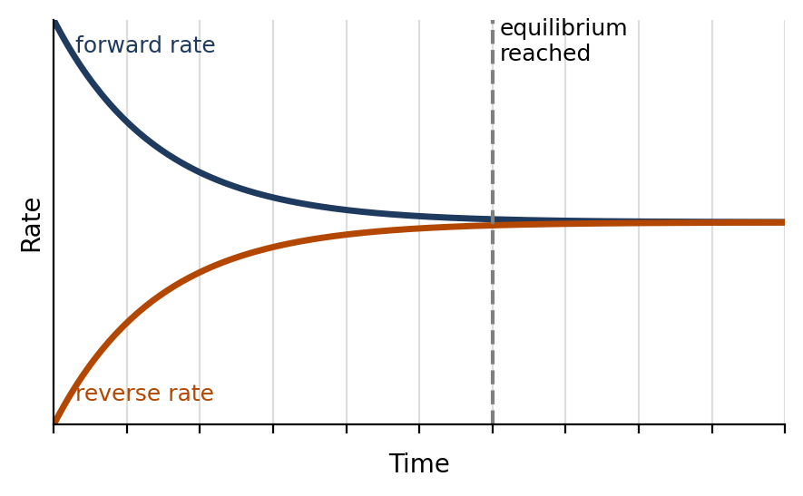

Common misconceptions
List three things that equilibrium does NOT mean or require:
Equilibrium does not mean the reaction has stopped.
Equilibrium does not mean the concentrations of reactants and products are equal.
Equilibrium can only be reached in a closed system (nothing enters or escapes).

Example: 2NO₂(g) ⇌ N₂O₄(g)
The initial pressure of NO₂ is 3.0 atm and no N₂O₄ is present. At equilibrium the pressure of NO₂ is 1.0 atm. Graph pressure vs. time for both gases. Label the axes with intervals (a scale for the vertical axis).
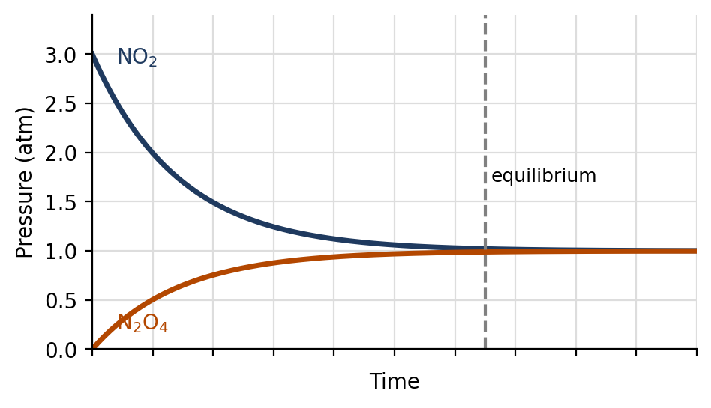
a) Pressure of N₂O₄ at equilibrium: 1.0 atm (NO₂ fell by 2.0 atm, and every 2 NO₂ make 1 N₂O₄).
b) Total pressure at equilibrium: 2.0 atm
c) K_{p} = = $\frac{1.0}{(1.0)²}$ = 1.0$\frac{P_{N₂O₄}}{(P_{NO₂})²}$

2. The Law of Chemical Equilibrium
For the reaction aA + bB ⇌ cC + dD:
Write the general expressions for K_{c} and K_{p}:
K_{c} = $\frac{[C]^{c} [D]^{d}}{[A]^{a} [B]^{b}}$
K_{p} = $\frac{(P_{C})^{c} (P_{D})^{d}}{(P_{A})^{a} (P_{B})^{b}}$

Rules for writing K
List the rules for writing K (top vs. bottom, exponents, what is left out, K_{c} vs. K_{p}, units, and what changes K):
Products go on the top and reactants on the bottom.
The coefficients become the exponents.
Pure solids and pure liquids are left out of K.
K_{c} uses molarity (mol/L). K_{p} uses partial pressures (atm) and only includes gases.
K has no units in AP Chemistry. K only changes with temperature.

What does the size of K mean?
Range of K | Meaning at equilibrium
K ≪ 1 | Reactant favored. Mostly reactants, very little product.
K ≫ 1 | Product favored. Mostly products.
K = 1 | Neither favored. Comparable amounts of reactants and products.
K > 1.0 × 10⁷ | Goes essentially to completion. Almost no reactant left.

What does K tell us about a reaction, and what does it NOT tell us?
K tells us how far a reaction goes, not how fast it goes.

Example: Write the equilibrium expression for CaCO₃(s) ⇌ CaO(s) + CO₂(g)
Wrong: K_{c} = $\frac{[CaO][CO₂]}{[CaCO₃]}$
Correct: K_{c} = [CO₂] K_{p} = P_{CO₂} (Solids are left out.)
Example: Write K_{c} and K_{p} for 2NH₃(g) ⇌ N₂(g) + 3H₂(g)
K_{c} = $\frac{[N₂][H₂]³}{[NH₃]²}$
K_{p} = $\frac{(P_{N₂})(P_{H₂})³}{(P_{NH₃})²}$

3. Solving for K and Concentrations Using an ICE Table
I = Initial, C = Change, E = Equilibrium.
List the steps for solving an ICE table problem:
1. Write the balanced equation and the K expression.
2. Fill in the Initial row. If a species is not present at the start, its initial value is 0.
3. Fill in the Change row: use −x for reactants and +x for products, multiplied by the coefficients.
4. Equilibrium = Initial + Change.
5. Use the given information to find x, then find the equilibrium values and K.

Example: COCl₂(g) ⇌ CO(g) + Cl₂(g)
3.0 mol of COCl₂ are added to a 1.5 L container at 650 K. At equilibrium [COCl₂] = 0.25 M. Calculate K_{c} and describe the equilibrium as reactant favored, product favored, or neither.
 | [COCl₂] | [CO] | [Cl₂]
I | 2.0 | 0 | 0
C | −x | +x | +x
E | 0.25 | 1.75 | 1.75

Initial [COCl₂] = $\frac{3.0 mol}{1.5 L}$ = 2.0 M.
2.0 − x = 0.25, so x = 1.75 M.
K_{c} = $\frac{[CO][Cl₂]}{[COCl₂]}$ = $\frac{(1.75)(1.75)}{0.25}$ = 12
K > 1, so the equilibrium is product favored.

Example: 2NH₃(g) ⇌ N₂(g) + 3H₂(g)
3.0 mol of NH₃ are placed in a 1.5 L container. At equilibrium [NH₃] = 0.5 M. Calculate K_{c} and describe the equilibrium as reactant favored, product favored, or neither.
 | [NH₃] | [N₂] | [H₂]
I | 2.0 | 0 | 0
C | −2x | +x | +3x
E | 0.5 | 0.75 | 2.25

Initial [NH₃] = $\frac{3.0 mol}{1.5 L}$ = 2.0 M.
2.0 − 2x = 0.5, so x = 0.75. Then [N₂] = 0.75 M and [H₂] = 3(0.75) = 2.25 M.
K_{c} = $\frac{[N₂][H₂]³}{[NH₃]²}$ = $\frac{(0.75)(2.25)³}{(0.5)²}$ = 34
K > 1, so the equilibrium is product favored.

4. Equilibrium with Partial Pressures (Dalton's Law)
State Dalton's law of partial pressures:
P_{t}otal = P₁ + P₂ + P₃ + … (the sum of the partial pressures).

Why can we use pressures in an ICE table instead of concentrations?
At constant volume and temperature, pressure is proportional to moles of gas, so an ICE table can be written with pressures instead of concentrations.

If the total pressure at equilibrium is given, how do we find x?
Add up the E row to get an equation for x.

Example: 2H₂(g) + O₂(g) ⇌ 2H₂O(g)
Initial pressures: P_{H₂} = 1.3 atm and P_{O₂} = 1.1 atm. The total pressure at equilibrium is 2.3 atm. Calculate K_{p}.
 | P_{H₂} | P_{O₂} | P_{H₂O}
I | 1.3 | 1.1 | 0
C | −2x | −x | +2x
E | 1.3 − 2x | 1.1 − x | 2x

P_{t}otal = (1.3 − 2x) + (1.1 − x) + 2x = 2.4 − x = 2.3, so x = 0.1 atm.
P_{H₂} = 1.1 atm, P_{O₂} = 1.0 atm, P_{H₂O} = 0.2 atm.
K_{p} = $\frac{(P_{H₂O})²}{(P_{H₂})² (P_{O₂})}$ = $\frac{(0.2)²}{(1.1)² (1.0)}$ = 0.033

Example: PCl₅(g) ⇌ PCl₃(g) + Cl₂(g)
The initial pressure of PCl₅ is 1.66 atm. At equilibrium the total pressure is 2.35 atm. Calculate K_{p}.
 | P_{PCl₅} | P_{PCl₃} | P_{Cl₂}
I | 1.66 | 0 | 0
C | −x | +x | +x
E | 1.66 − x | x | x

P_{t}otal = (1.66 − x) + x + x = 1.66 + x = 2.35, so x = 0.69 atm.
P_{PCl₅} = 1.66 − 0.69 = 0.97 atm. P_{PCl₃} = P_{Cl₂} = 0.69 atm.
K_{p} = $\frac{(0.69)(0.69)}{0.97}$ = 0.49

Example: Br₂(g) + I₂(g) ⇌ 2IBr(g), K_{p} = 70
0.25 atm of Br₂ is combined with 0.25 atm of I₂. What is P_{IBr} at equilibrium? What is the total pressure?
 | P_{Br₂} | P_{I₂} | P_{IBr}
I | 0.25 | 0.25 | 0
C | −x | −x | +2x
E | 0.25 − x | 0.25 − x | 2x

K_{p} = $\frac{(2x)²}{(0.25 − x)²}$ = 70. Both sides are perfect squares, so take the square root.
= 8.37, so 2x = 2.09 − 8.37x, then 10.37x = 2.09 and x = 0.20.$\frac{2x}{0.25 − x}$
P_{IBr} = 2x = 0.40 atm. P_{Br₂} = P_{I₂} = 0.25 − 0.20 = 0.05 atm.
Total pressure = 0.05 + 0.05 + 0.40 = 0.50 atm (the moles of gas do not change: 2 mol → 2 mol).

5. When Can We Ignore −x? (Small K Approximation)
When can we use the small-x approximation? Describe the conditions and what it lets us do:
If K is very small (roughly K < 10⁻³) and the initial concentration is large, very little reacts, so x is tiny.
Then (initial − x) ≈ initial, and the math is much easier.
Do not use the approximation when K is large or the initial concentration is very small.

Example: H₂CO₃(aq) ⇌ H⁺(aq) + HCO₃⁻(aq), K_{c} = 4.3 × 10⁻⁷
Determine [HCO₃⁻] if the initial [H₂CO₃] = 1.20 M.
 | [H₂CO₃] | [H⁺] | [HCO₃⁻]
I | 1.20 | 0 | 0
C | −x | +x | +x
E | 1.20 − x ≈ 1.20 | x | x

K_{c} = $\frac{x²}{1.20 − x}$ ≈ $\frac{x²}{1.20}$ = 4.3 × 10⁻⁷
x² = 5.2 × 10⁻⁷, so x = 7.2 × 10⁻⁴
[HCO₃⁻] = 7.2 × 10⁻⁴ M

Example: N₂(g) + O₂(g) ⇌ 2NO(g), K_{c} = 4.2 × 10⁻⁸
The initial [N₂] = 0.085 M and [O₂] = 0.038 M. What is [NO] at equilibrium?
 | [N₂] | [O₂] | [NO]
I | 0.085 | 0.038 | 0
C | −x | −x | +2x
E | 0.085 − x ≈ 0.085 | 0.038 − x ≈ 0.038 | 2x

K_{c} = $\frac{(2x)²}{(0.085 − x)(0.038 − x)}$ ≈ $\frac{4x²}{(0.085)(0.038)}$ = 4.2 × 10⁻⁸
4x² = 1.36 × 10⁻¹⁰, so x² = 3.4 × 10⁻¹¹ and x = 5.8 × 10⁻⁶
[NO] = 2x = 1.2 × 10⁻⁵ M

6. Manipulating Reactions and the Effect on K
If you… | Then K…
Multiply all coefficients by n | is raised to the power n: K^{n}
Reverse the reaction | becomes the reciprocal: $\frac{1}{K}$
Add two or more reactions together | are multiplied: K = K₁ × K₂ × …

Example: 2A + B ⇌ 3C, K_{c} = 2.5 × 10⁻³
How does each change affect K_{c}?
a) 4A + 2B ⇌ 6C K_{c} = (2.5 × 10⁻³)² = 6.3 × 10⁻⁶ (coefficients ×2)
b) A + ½B ⇌ (3/2)C K_{c} = (2.5 × 10⁻³)^{½} = 0.050 (coefficients ×½)
c) 3C ⇌ 2A + B K_{c} = = 400$\frac{1}{2.5 × 10⁻³}$ (reversed)
Example: Calculate K_{c} for 2N₂O + 3O₂ ⇌ 2N₂O₄
Rxn 1: 2N₂ + O₂ ⇌ 2N₂O K_{c} = 1.2 × 10⁻³⁵
Rxn 2: N₂O₄ ⇌ 2NO₂ K_{c} = 4.6 × 10⁻³
Rxn 3: ½N₂ + O₂ ⇌ NO₂ K_{c} = 4.1 × 10⁻⁹
Goal: manipulate the given reactions so they add up to the overall reaction. Manipulate K in the same way.
Rxn 1 reversed: 2N₂O ⇌ 2N₂ + O₂, K = $\frac{1}{K₁}$
Rxn 2 reversed and ×2: 4NO₂ ⇌ 2N₂O₄, K = $\frac{1}{(K₂)²}$
Rxn 3 ×4: 2N₂ + 4O₂ ⇌ 4NO₂, K = (K₃)⁴
Add them. The 2N₂, the 4NO₂, and one O₂ cancel, leaving 2N₂O + 3O₂ ⇌ 2N₂O₄.
K_{c} = $\frac{(K₃)⁴}{K₁ (K₂)²}$ = $\frac{(4.1 × 10⁻⁹)⁴}{(1.2 × 10⁻³⁵)(4.6 × 10⁻³)²}$ = 1.1 × 10⁶

7. The Reaction Quotient (Q)
Define the reaction quotient, Q:
Q is written exactly like K, but using the concentrations or pressures at any moment in time (not just at equilibrium).

How is Q different from K?
Q tells us where the reaction is now. K tells us where it is headed.

Comparison | Meaning | Shift
Q < K | Too many reactants (not enough products) | Shifts right →
Q = K | At equilibrium | No shift
Q > K | Too many products (not enough reactants) | ← Shifts left

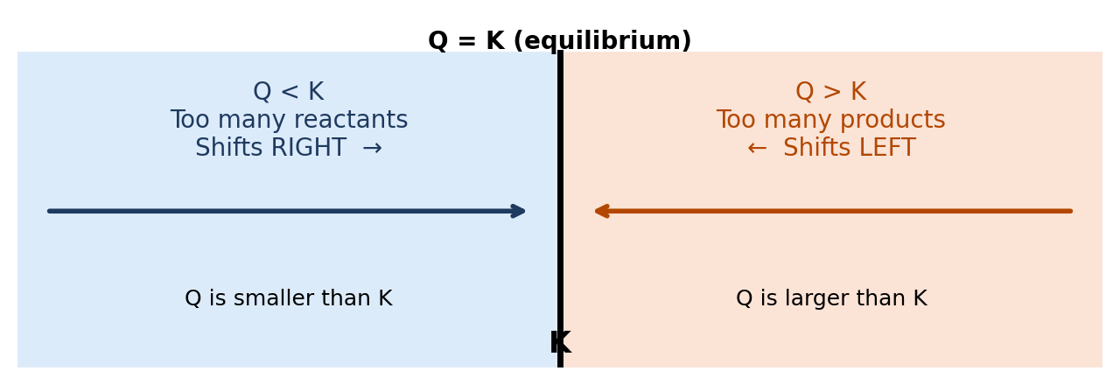
Steps: (1) write Q, (2) substitute the current values (change moles to M if needed), (3) compare Q to K, (4) decide the shift.
Example: N₂(g) + 3H₂(g) ⇌ 2NH₃(g), K_{p} = 1.64 × 10⁻⁴
A closed vessel contains 1.5 atm N₂, 3.2 atm H₂, and 0.75 atm NH₃.
a) How do we check if the reaction is at equilibrium?
Calculate Q and compare it to K.

b) Is the reaction at equilibrium? If not, which way does it shift?
Q_{p} = $\frac{(P_{NH₃})²}{(P_{N₂})(P_{H₂})³}$ = $\frac{(0.75)²}{(1.5)(3.2)³}$ = $\frac{0.5625}{49.2}$ = 1.1 × 10⁻²
Q > K, so it is not at equilibrium. It shifts left (toward reactants).

Example: SO₂Cl₂(g) ⇌ SO₂(g) + Cl₂(g), K_{c} = 0.078 at 100 °C
0.035 mol SO₂, 0.500 mol SO₂Cl₂, and 0.080 mol Cl₂ are combined in a sealed 5.00 L flask at 100 °C. Is the reaction at equilibrium? If not, which way does it shift?
[SO₂] = $\frac{0.035}{5.00}$ = 0.0070 M, [SO₂Cl₂] = $\frac{0.500}{5.00}$ = 0.100 M, [Cl₂] = $\frac{0.080}{5.00}$ = 0.016 M
Q_{c} = $\frac{[SO₂][Cl₂]}{[SO₂Cl₂]}$ = $\frac{(0.0070)(0.016)}{0.100}$ = 1.1 × 10⁻³
Q < K, so it is not at equilibrium. It shifts right (toward products).

Example: At 445 °C, K_{c} = 0.020 for 2HI(g) ⇌ H₂(g) + I₂(g)
[HI] = 2.0 M, [H₂] = 0.50 M, [I₂] = 0.10 M. Which statement is TRUE?
(a) Q_{c} = K_{c}; the system is at equilibrium.
(b) Q_{c} is less than K_{c}; more H₂ and I₂ will be produced.
(c) Q_{c} is less than K_{c}; more HI will be produced.
(d) Q_{c} is greater than K_{c}; more H₂ and I₂ will be produced.
(e) Q_{c} is greater than K_{c}; more HI will be produced.
Q_{c} = $\frac{[H₂][I₂]}{[HI]²}$ = $\frac{(0.50)(0.10)}{(2.0)²}$ = 0.0125
Q < K, so the reaction shifts right, making more H₂ and I₂. Answer: (b)

8. Le Châtelier's Principle
State Le Châtelier's principle:
If a system at equilibrium is disturbed (stressed), the system shifts in the direction that partially reduces the stress and a new equilibrium is established.

What does a shift right or left mean? Does a shift fully cancel the stress?
A shift right makes more products. A shift left makes more reactants. The shift reduces the stress but does not eliminate it. Every shift can be explained with Q vs K.

There are 4 types of stress: concentration, temperature, volume of gases, and volume of solutions.

Stress 1: Concentration (or Partial Pressure)
Stress | Q compared with K | Shift
Add a reactant | Q < K | Right →
Remove a reactant | Q > K | ← Left
Add a product | Q > K | ← Left
Remove a product | Q < K | Right →

What happens if a solid or pure liquid is added or removed?
Solids and pure liquids do not appear in K, so adding or removing them causes no shift.

Example: N₂(g) + 3H₂(g) ⇌ 2NH₃(g)
Fill in the effect on each species as the system shifts. Use ↑ (increases), ↓ (decreases). The arrows describe what happens after the stress, as the system shifts.
Stress | Shift | [N₂] | [H₂] | [NH₃]
Add N₂ | Right | ↓ | ↓ | ↑
Add H₂ | Right | ↓ | ↓ | ↑
Add NH₃ | Left | ↑ | ↑ | ↓
Remove NH₃ | Right | ↓ | ↓ | ↑

(The added or removed substance itself moves back part of the way toward its original value as the system shifts.)
Example: N₂O₄(g) ⇌ 2NO₂(g)
a) Write K_{c}:
K_{c} = $\frac{[NO₂]²}{[N₂O₄]}$

b) The system is at equilibrium. At the dashed line, extra NO₂ is added. Sketch how both concentrations change until a new equilibrium is reached.
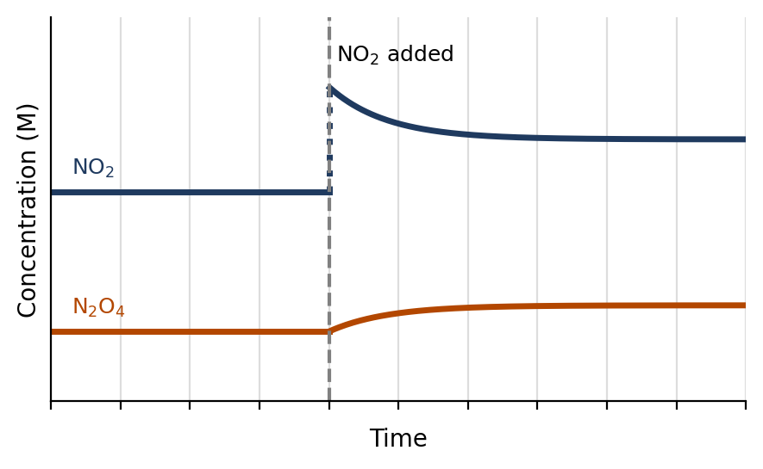
c) Use Q to explain:
Adding NO₂ makes Q > K. The reaction shifts left, so NO₂ decreases (from the jump) and N₂O₄ increases until Q = K again.

d) On the graph below, show what happens if extra N₂O₄ is added instead. Use Q to explain.
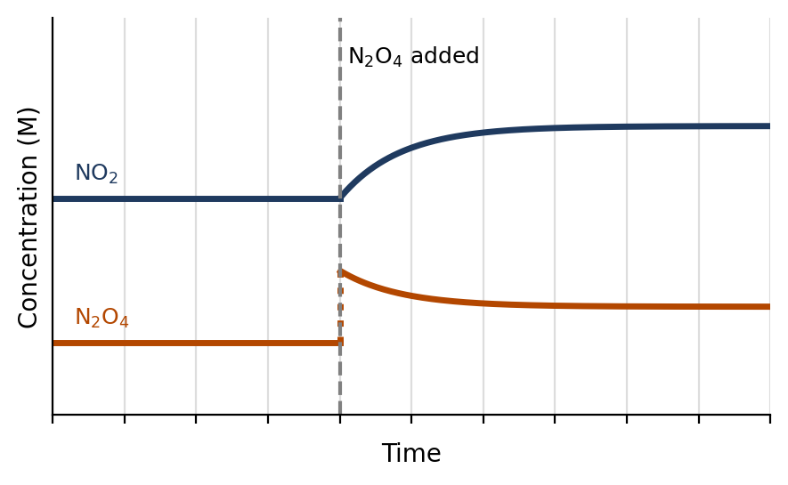
Use Q to explain:
Adding N₂O₄ makes Q < K. The reaction shifts right, so N₂O₄ decreases (from the jump) and NO₂ increases until Q = K again.

Stress 2: Temperature
What is affected by temperature?
The value of K. Temperature is the only stress that changes K.

To predict the shift, write heat into the equation:
Reaction type | ΔH | Heat is a… | Increase T | Decrease T | K when T increases
Exothermic | negative (−) | product | Shifts left | Shifts right | decreases
Endothermic | positive (+) | reactant | Shifts right | Shifts left | increases

Example: Exothermic: A + B ⇌ C + heat, K_{c} = 200 at 25 °C
The temperature is increased to 30 °C. Shift: left K: decreases
The temperature is lowered to 20 °C. Shift: right K: increases
Example: Endothermic: heat + A + B ⇌ C, K_{c} = 200 at 25 °C
The temperature is increased to 30 °C. Shift: right K: increases
The temperature is lowered to 20 °C. Shift: left K: decreases
Example: N₂(g) + 3H₂(g) ⇌ 2NH₃(g), ΔH = −92 kJ/mol
a) Where is the heat in the reaction?
ΔH is negative (exothermic), so heat is a product: N₂ + 3H₂ ⇌ 2NH₃ + heat

b) The temperature is lowered. Which way does it shift? Use K and Q to explain.
It shifts right.
Lowering the temperature removes heat, and an exothermic reaction has K that increases at lower T. Now Q < the new K, so the reaction shifts right to make more NH₃ until Q = K again.

Stress 3: Volume of Gases (change in container size)
Example: N₂(g) + 3H₂(g) ⇌ 2NH₃(g)
The reaction is at equilibrium in a 3.0 L container. The gases are moved into a 1.5 L container. Use Q to explain the effect on equilibrium.
Halving the volume doubles every concentration.
Q = $\frac{[NH₃]²}{[N₂][H₂]³}$. The top is multiplied by 2² = 4. The bottom is multiplied by 2 × 2³ = 16.
Q is now $\frac{4}{16}$ = $\frac{1}{4}$ of K, so Q < K and the reaction shifts right, toward the side with fewer moles of gas.

Fast way to determine the shift:
Fast way to determine the shift for volume changes of gases:
Decrease the volume (increase the pressure): shifts toward the side with fewer moles of gas. Increase the volume (decrease the pressure): shifts toward the side with more moles of gas. Equal moles of gas on both sides: no shift. Count only gases (g); do not count solids, liquids, or aqueous species.

Stress 4: Volume of Solutions (adding solvent)
Example: HC₂H₃O₂(aq) ⇌ H⁺(aq) + C₂H₃O₂⁻(aq), K_{c} = 1.8 × 10⁻⁵
a) Write K_{c}:
K_{c} = $\frac{[H⁺][C₂H₃O₂⁻]}{[HC₂H₃O₂]}$

b) 2.0 L of H₂O is added to 1.0 L of 1.0 M acetic acid. Do the moles of C₂H₃O₂⁻ increase, decrease, or stay the same? Use Q to explain.
The total volume goes from 1.0 L to 3.0 L, so every concentration is divided by 3.
Q: the top is divided by 3² = 9 and the bottom is divided by 3, so Q = $\frac{1}{3}$ K.
Q < K, so the reaction shifts right. The moles of C₂H₃O₂⁻ increase (but the concentration is still lower because of the extra water).

Fast way to determine the shift when solvent is added or removed:
Adding solvent (dilution) shifts toward the side with more dissolved particles (moles of aqueous species). Evaporating solvent shifts toward the side with fewer.

Non-stressors: things that do NOT shift equilibrium
Catalyst: what does it do to equilibrium?
A catalyst speeds up the forward and reverse reactions equally. K and the position of equilibrium do not change; equilibrium is just reached faster.

Surface area of a solid reactant: what does it do to equilibrium?
It changes the rate only. Solids are not in K, so there is no shift.

Adding a non-reactive gas (constant volume): what does it do to equilibrium?
The partial pressures of the reacting gases do not change, so Q is unchanged and there is no shift.

9. Summary
Stress | Shift | Does K change?
Add reactant / remove product | Right → | No
Add product / remove reactant | ← Left | No
Increase T (endothermic) | Right → | Yes, K increases
Increase T (exothermic) | ← Left | Yes, K decreases
Decrease volume (gases) | Toward fewer moles of gas | No
Increase volume (gases) | Toward more moles of gas | No
Add solvent (dilute) | Toward more dissolved particles | No
Catalyst, solid surface area, inert gas | No shift | No

Exit Ticket
1) Write K_{c} for 2SO₂(g) + O₂(g) ⇌ 2SO₃(g).
K_{c} = $\frac{[SO₃]²}{[SO₂]²[O₂]}$

2) If K_{c} = 4.0 for the reaction in question 1, what is K_{c} for 2SO₃(g) ⇌ 2SO₂(g) + O₂(g)?
K = $\frac{1}{4.0}$ = 0.25

3) For N₂O₄(g) ⇌ 2NO₂(g), K_{c} = 0.36. A mixture has [N₂O₄] = 0.020 M and [NO₂] = 0.100 M. Which way does it shift?
Q = $\frac{(0.100)²}{0.020}$ = 0.50. Q > K, so it shifts left.

4) An exothermic reaction at equilibrium is heated. Which way does it shift, and what happens to K?
It shifts left, and K decreases.

5) For 2A(g) ⇌ B(g), what happens if the volume of the container is decreased?
It shifts right, toward B, because there is 1 mole of gas on the right and 2 on the left.

6) Which stress changes the value of K?
Only a change in temperature.

